# Kleurenstal



# Sitemap

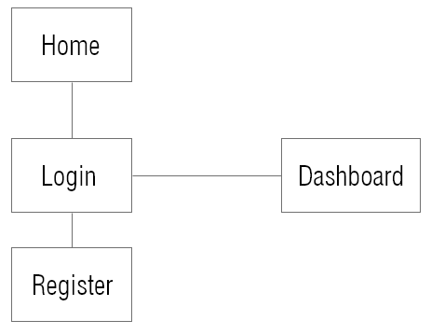

# DFD

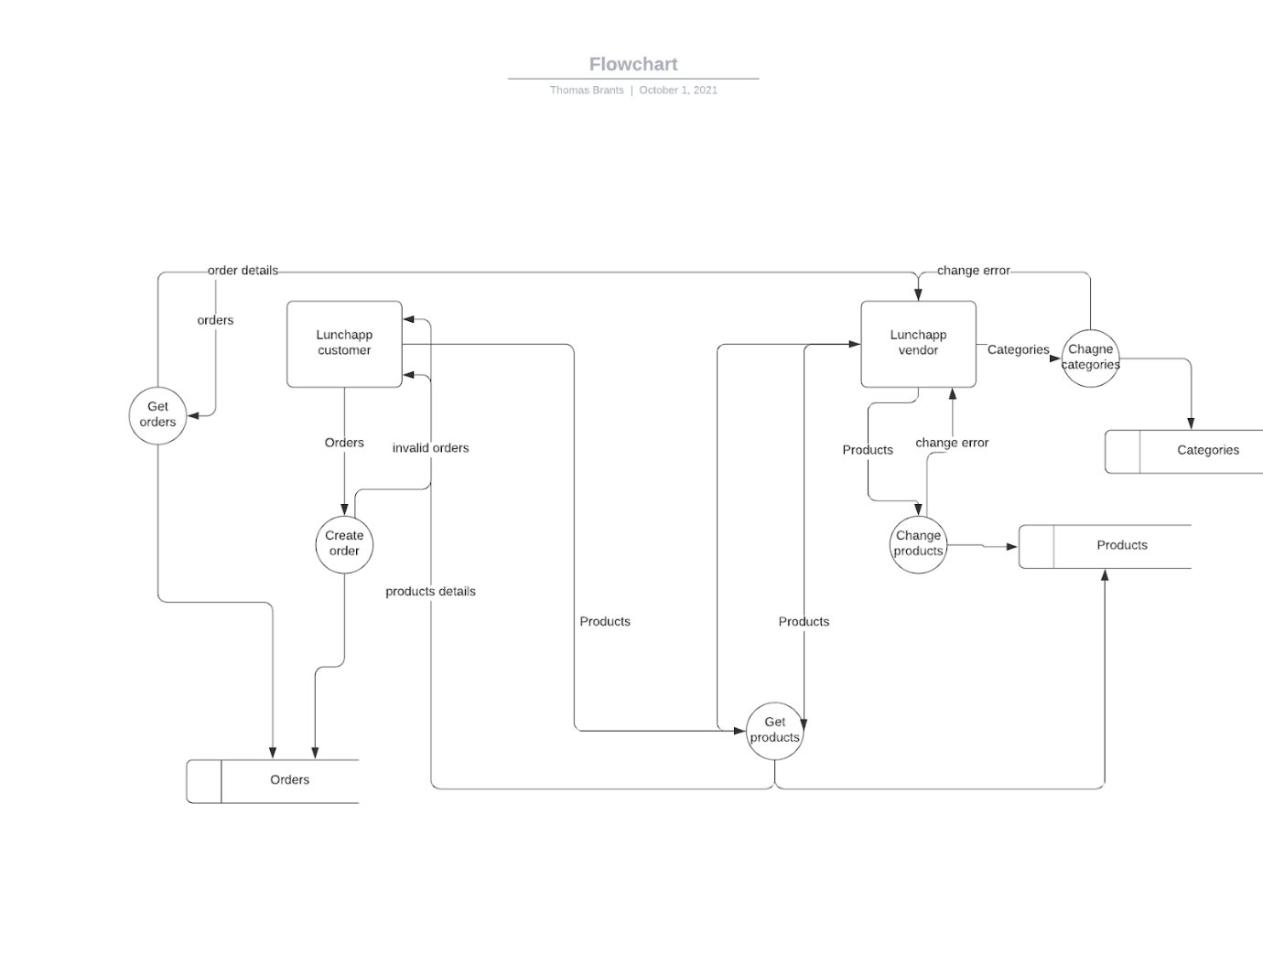

# ERD

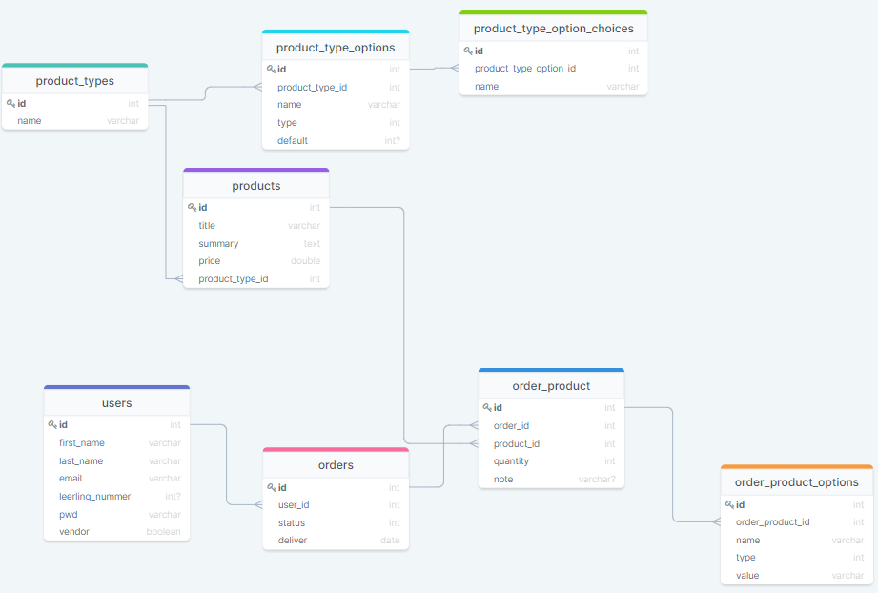

# Database specification

users(id,first_name,last_name,email,leerling_nummer,pwd,vendor)

products(id,title,summary,price,<category_id>,<product_type_id>)

product_types(id,name)

product_type_options(id,<product_type_id>, name, type, default)

product_type_option_choice(id,<product_type_option_id>,name)

orders(id,<user_id>,status,deliver)

order_product(id,<order_id>,<product_id>,quantity,note)

order_product_options(id,<order_product_id>,name,type,value)

# Wireframes

## Home

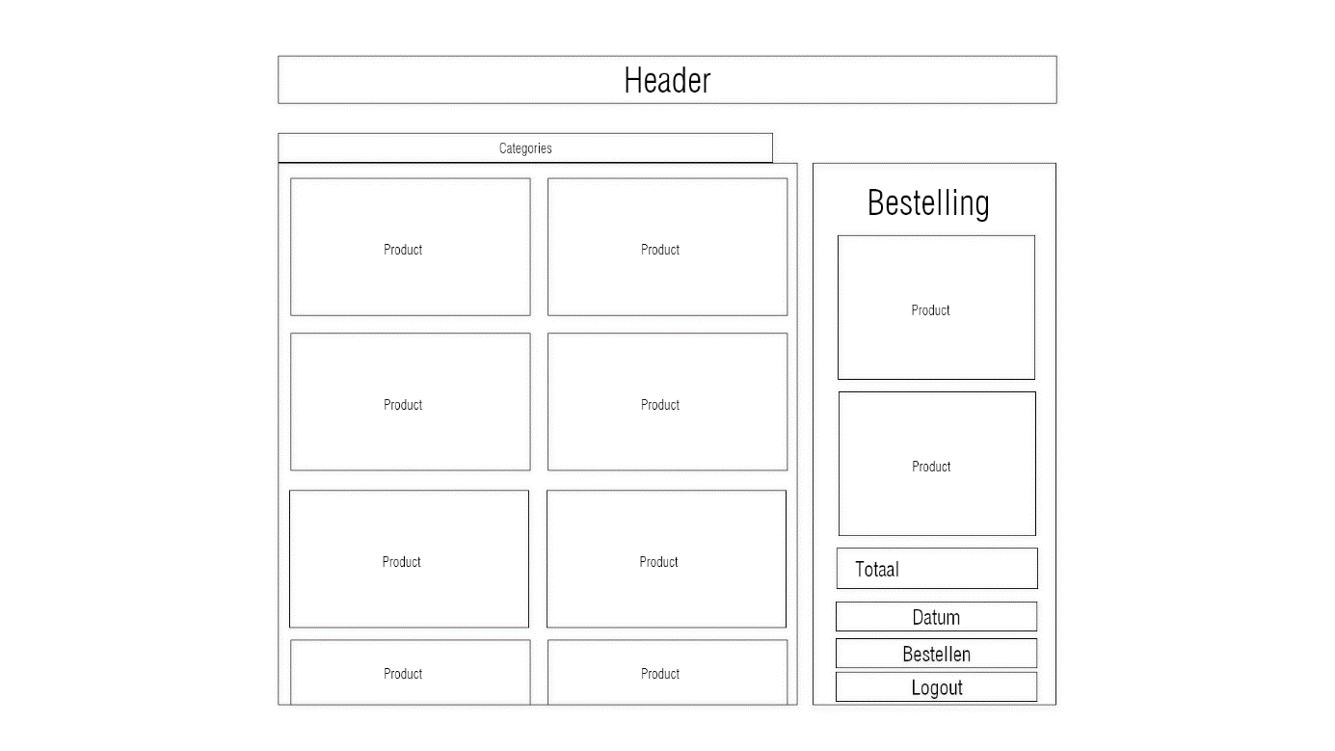

## Login

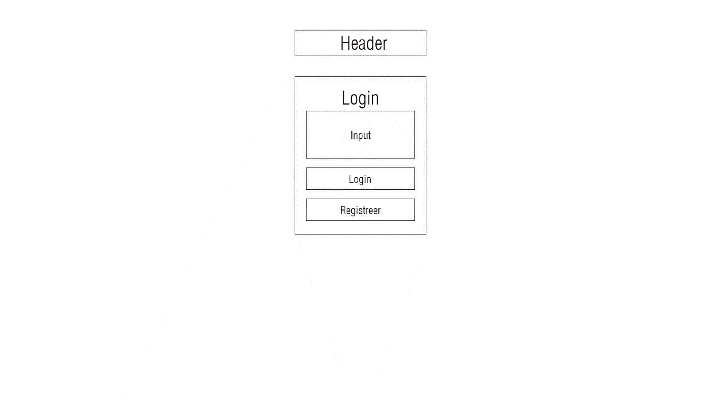

## Register

# Designs

## Home

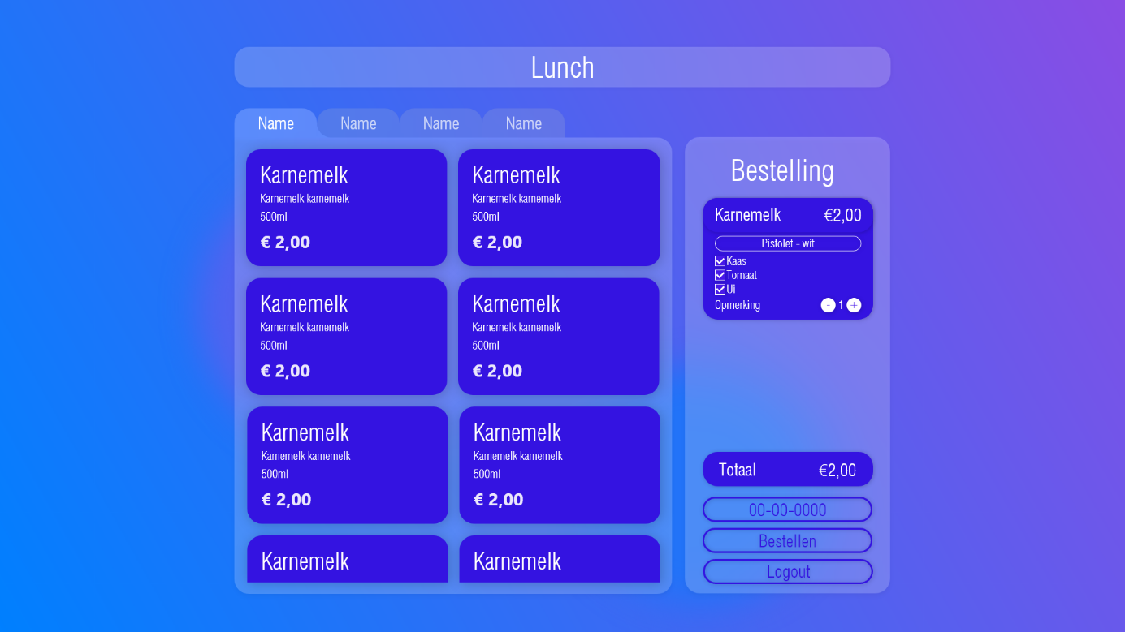

## Login

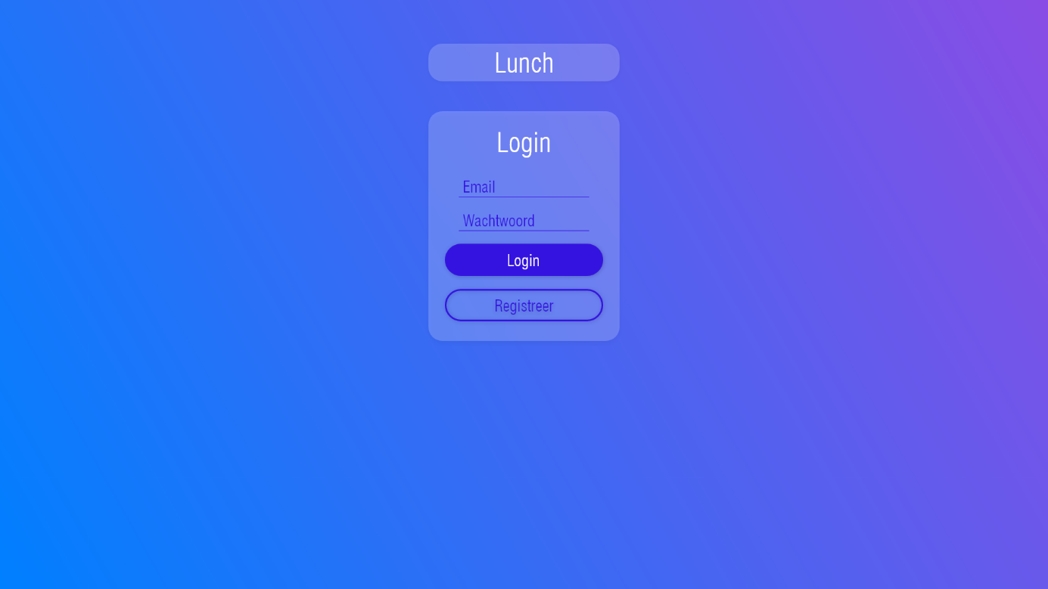

## Register